HOME PAGE AMENDMENTS

- Please change the below image for a girl who looks more friendly and less depressed looking . The other images here are fine 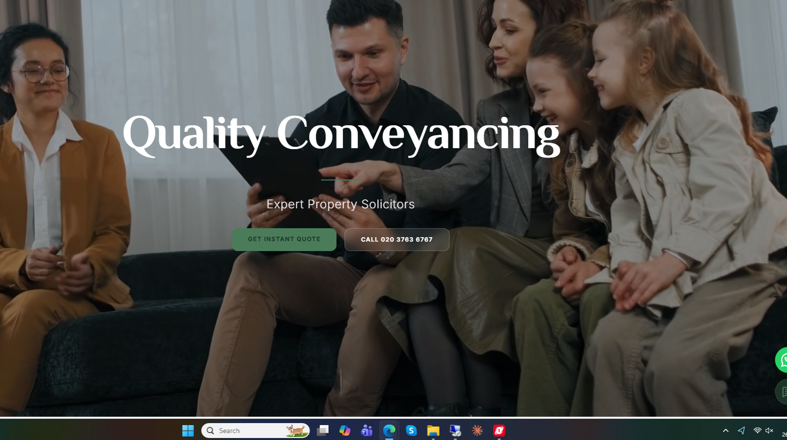

2)We dont like the image of the house below. Also please remove the section and the image and move just the information section to “Meet the team” page

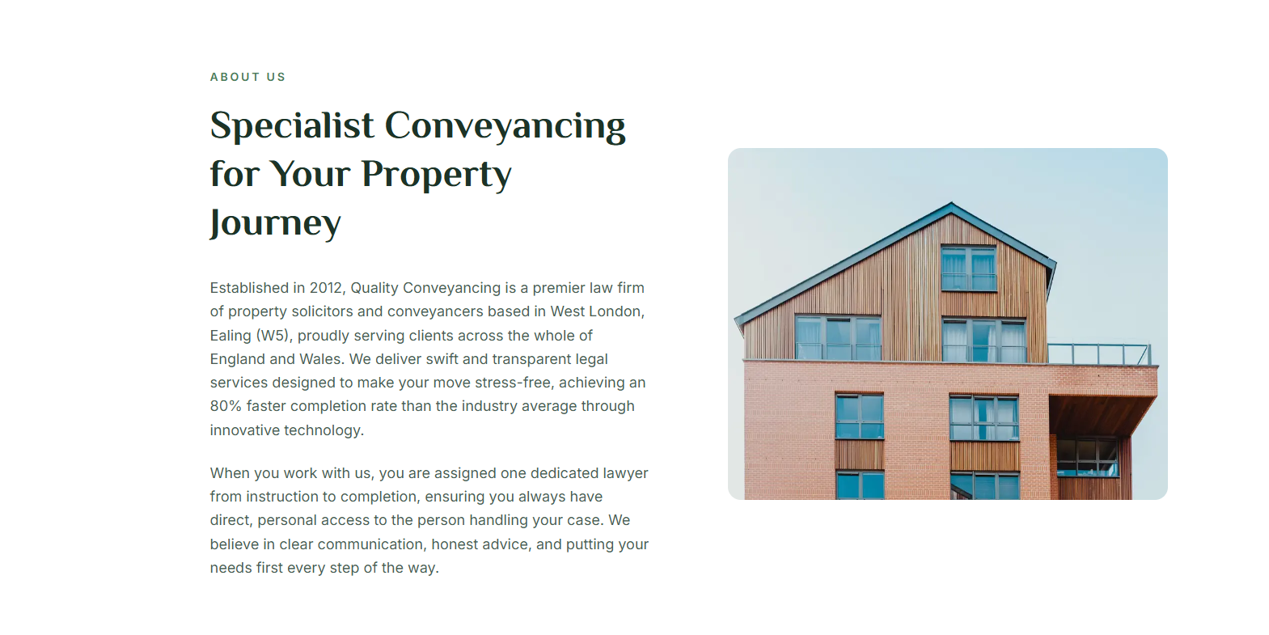
The quote generator should be at the top of the home page after the moving images

- Quote generator
We need to work on this quote generator:

- What can we help with : needs an option also for “Commercial Purchase” and”commercial sale”

- For commercial property use this site to help you with the questions : https://gdlegal.co.uk/commercial-conveyancing-quote/ once a customer has competed these questions we dont actually want to give them a quote, we need to say

* Thank you for requesting a commercial conveyancing quote with us. To ensure we provide the most accurate, custom-tailored pricing for your specific transaction, one of our commercial specialists will review your information and contact you. Alternatively, please call us on 020 3763 6767 and speak to one of our friendly team members right away. We look forward to speaking with you!

- If you have any urgent questions in the meantime, please feel free to give us a call or send us an email. We look forward to speaking with you!

- You can remove number of buyers as this not relevant
- Freehold options are also not relevant
- Depending on the type of property there are follow up questions that need to be answered as below
- When the client completes the questions they should then get an instant quote sent to them via email but should also be able to see the instant quote online, which I like the way you show presently

Please use the questions from these two sites amd combine them as one. The instant quote generator is a very important function for our site and needs to work efficiently and gather the information. From the information completed the client then needs to get an instant quote.

- At the end of the instant quote we need the below in bold;
* We may have seasonal discounts available for your quote. Please get in touch at 020 3763 6767to discuss

Compare Conveyancing Quotes Online & Save on Fees and Find Verified and Trusted Conveyancers | Konnect You

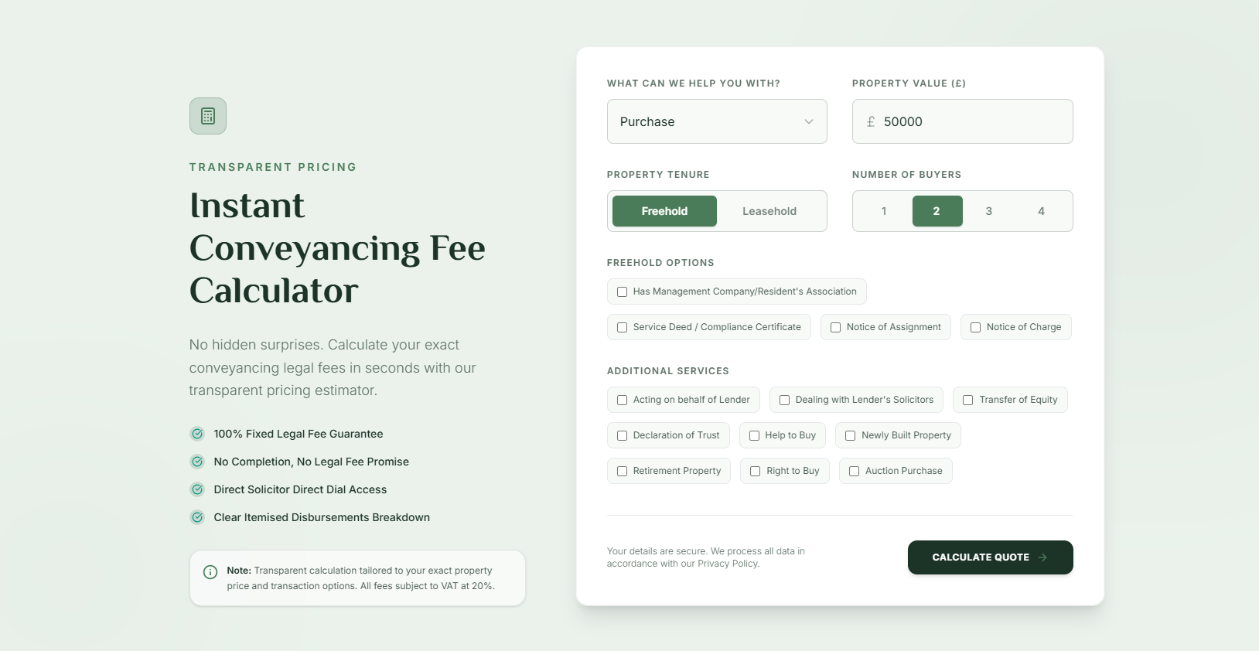

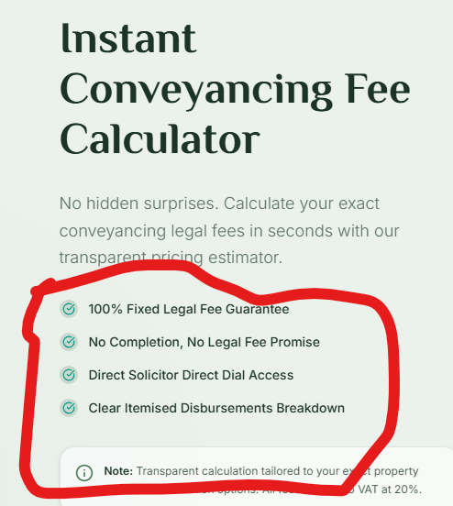
Please amend the ticks above
- Remove 100% fixed legal fee - we do not offer this. Replace with *Transparent Quotes
- Remove no completion , no legal fee promise and replace with : Highly Skilled & Experienced Lawyers
- Other ones are fine
- Add these ones :
  - On panel of all major lenders
  - 80% Faster Than Industry Average
  - 5-Star Rated Service

- Add a link to our endorsement page with “What Our Clients Say..
- ”In this section also please add “ Refer A Friend & Receive £100, Click Here” this should take them to our referral page

3) “The process” should be next
Replace “Clear expert Guidance” with “What Happens Next”

01: Instruction
If you are happy to instruct us , we will send you a Welcome Pack for you to complete and return to us. You will also be assigned a dedicated Lawyer

Afer 02 - before 03 add :
Conveyancing Report :
Once title checks are complete, we’ll send you the conveyancing report along with the legal documents for you to sign and return."

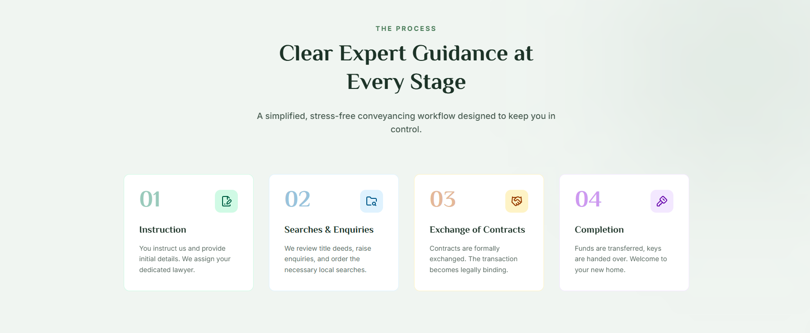

4) Reviews should be after the process

I dont like the way the reviews are displayed 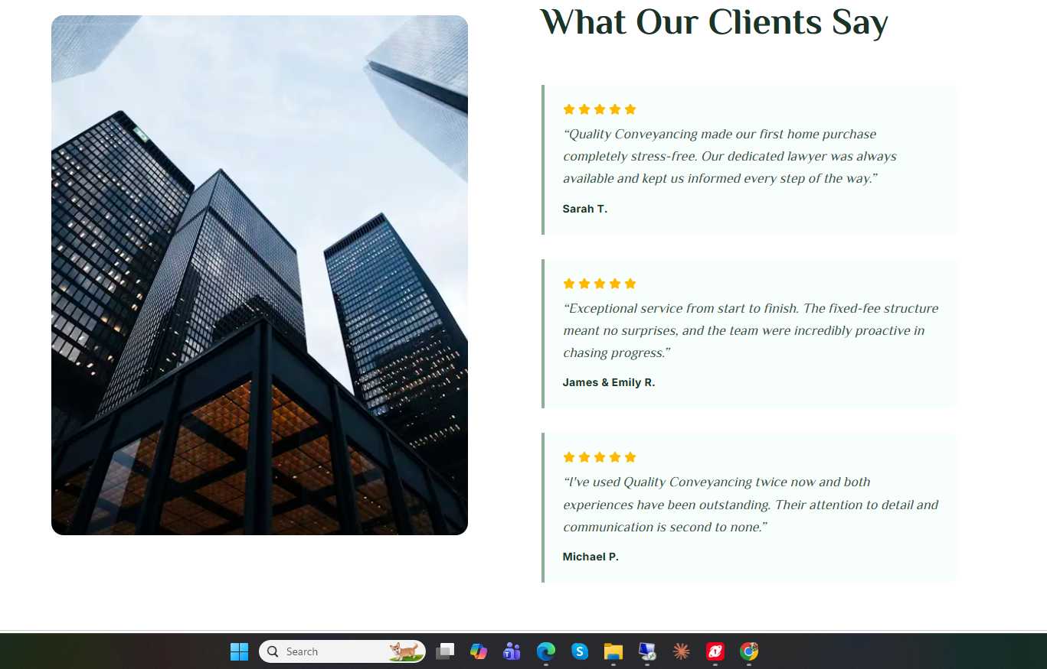

Can you amend them so they show as below with a similar image (Get An Instant Conveyancing Quote Online | Setfords )
Show about 10 quotes, pick the best ones from our google reviews



4) After this should be FAQs,
Remove the “What are your conveyancing fees” the other questions and answers are fine but also add the ones missed from the site : their questions and answers are good, Residential Conveyancing - ADK Law Solicitors : ADK Law Solicitors

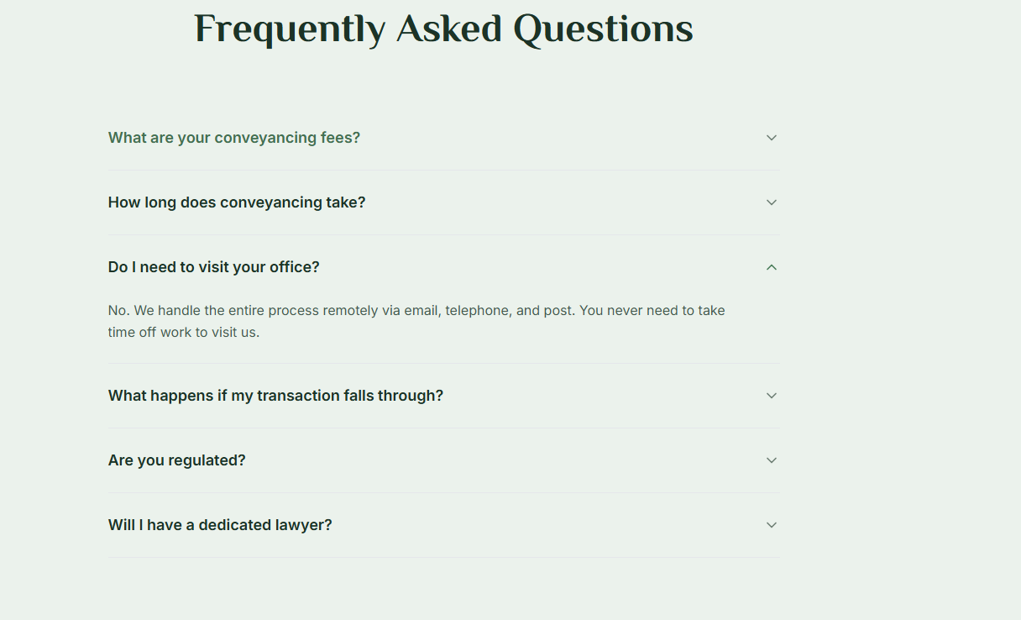

5) next add this section
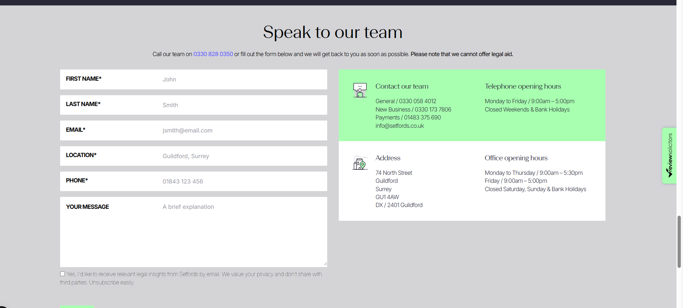

5) move the below form home page to our services

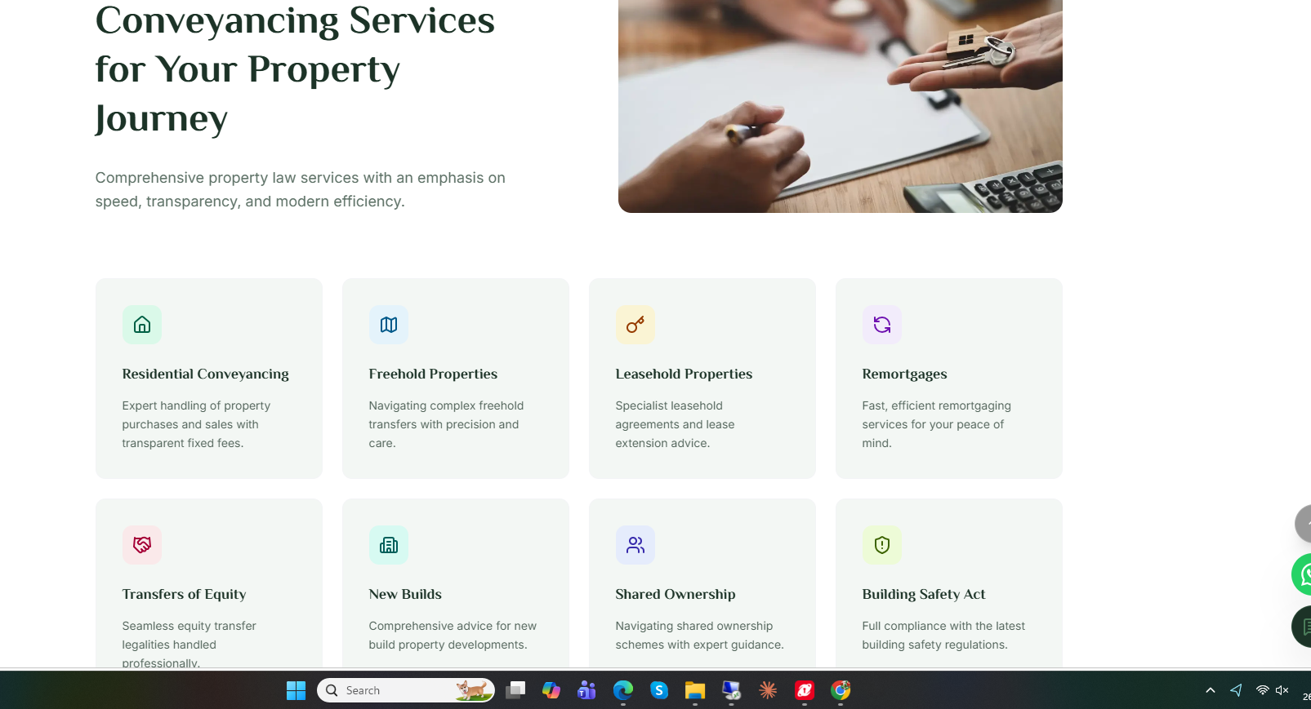
5) Remove this 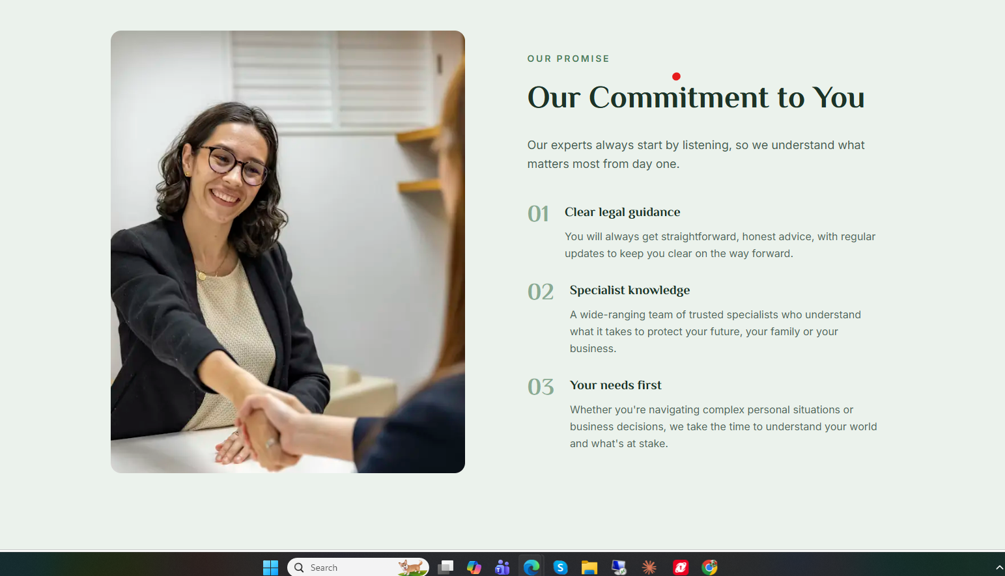
5) move the below form home page to meet the team

Add “Refer Work” page

OUR SERVICES PAGE AMENDMENTS

- Shift this section up to show first until the black heading. Remove reference to “Get Fixed Fee Quote” to “Get A Quote”. Any reference to fixed fee on the site must be removed as this is not something we offer
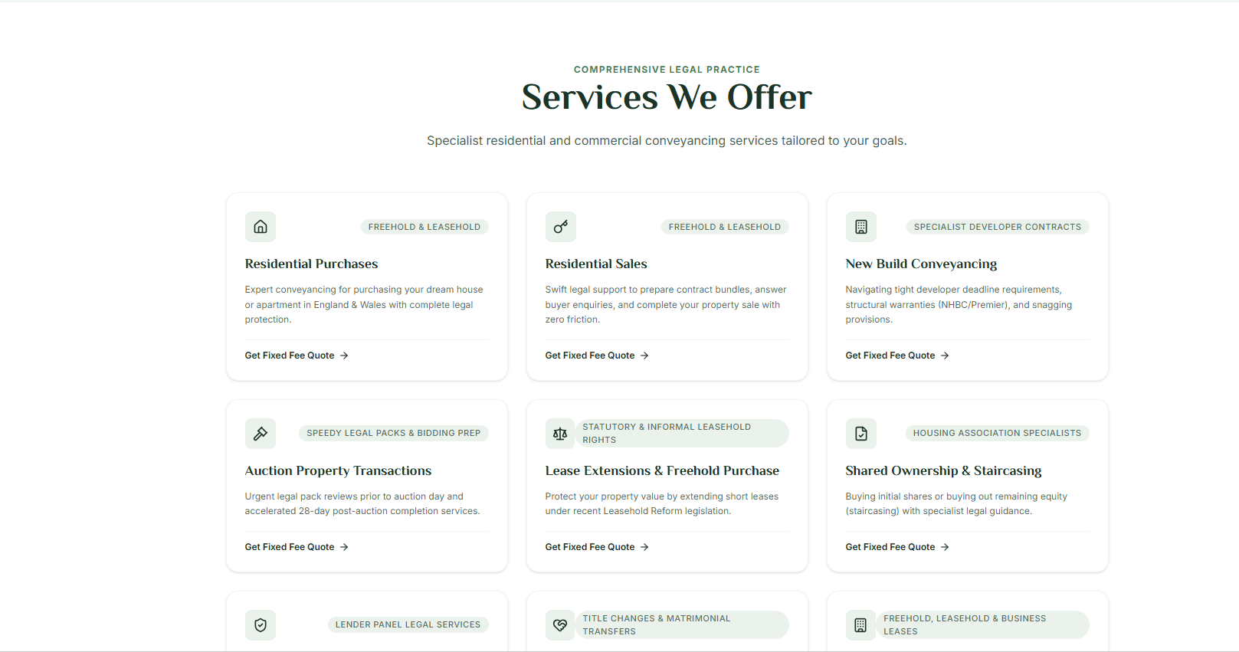
- Amend title :”We Serve The Best Conveyancing Service in the UK” to “We Provide The Best Conveyancing Service In The UK”
- Remove 100% fixed fee perhaps replace with “Trusted by our clients”

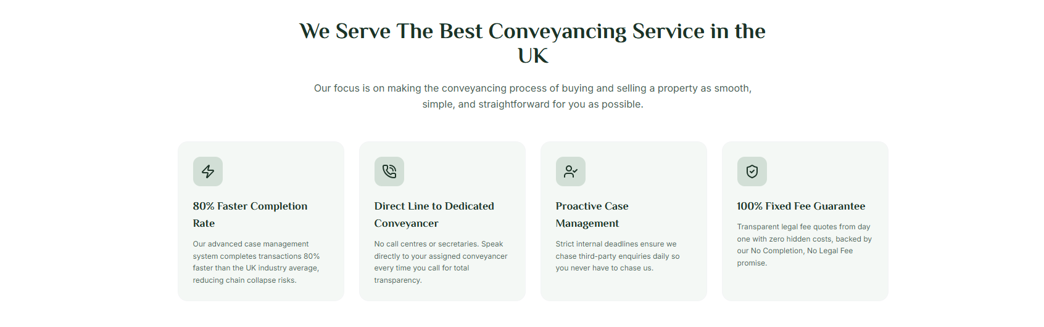

GET A QUOTE PAGE

Remove all references to fixed fee and no completion no fee from this page and from the site as a whole please .

Rest is fine

MEET THE TEAM

- Please adjust the picture to make our faces and body to look more like us
- Remove all reference to no completion no fee
- Change “operations & PA” to “Business Development” and add Pat,Vijay, & Ewa

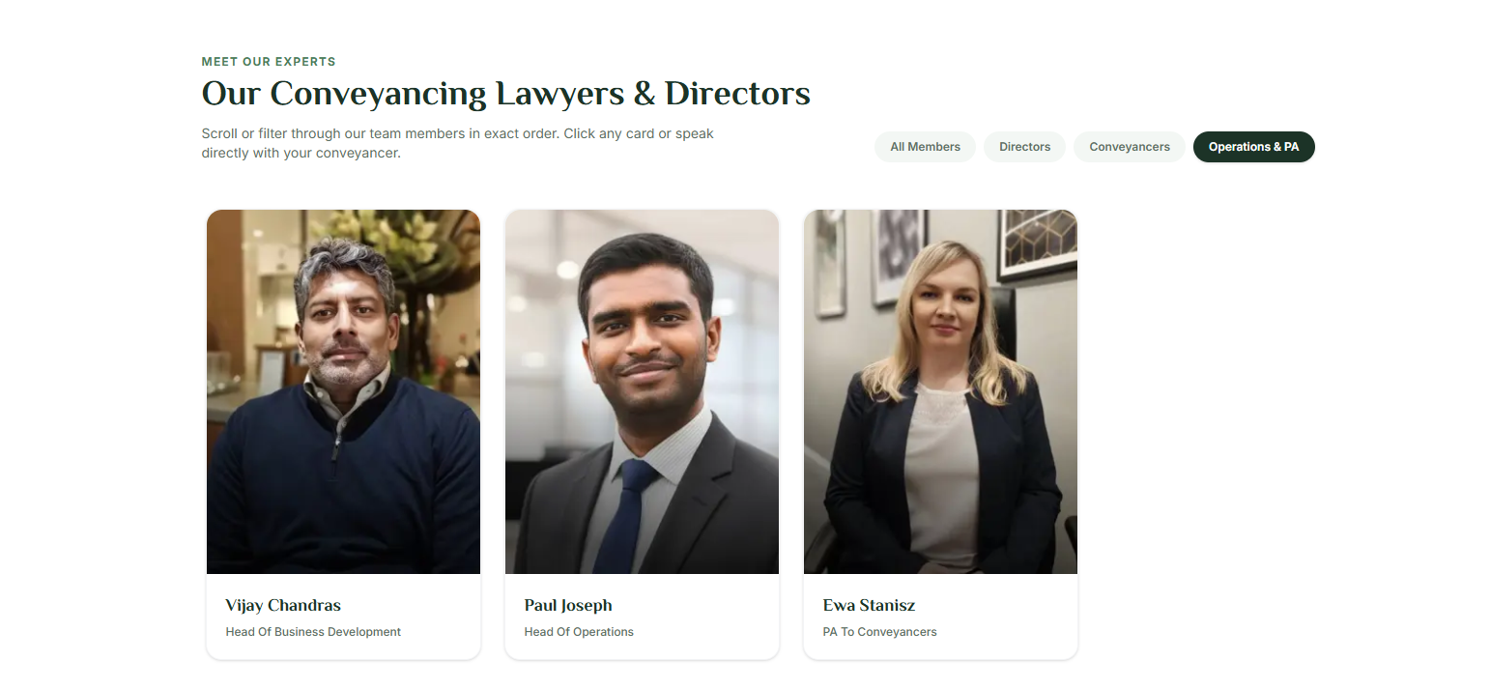

- For Pat - Add Director(Senior Solicitor)
Jay ( Director- Licensed Conveyancer)

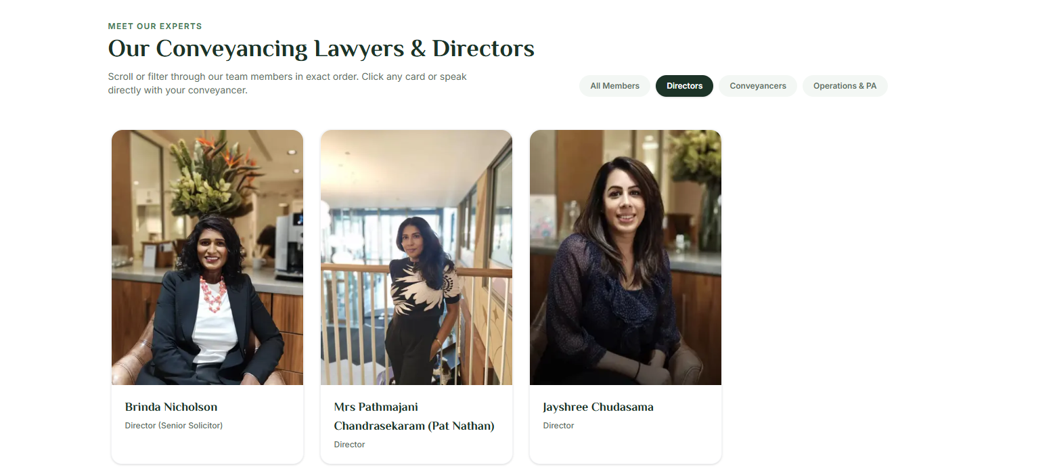

REFER TO US

Replace with “Careers Page”

We want to create something similar to this
Introducer Partners | Alecto and Refer a friend - Smart Legal | Clear & Reliable Conveyancing Solicitors

Similar to below we would want “Become a Referrer” and “Refer a Friend/Family” when they click this a similar form should pop up as below;


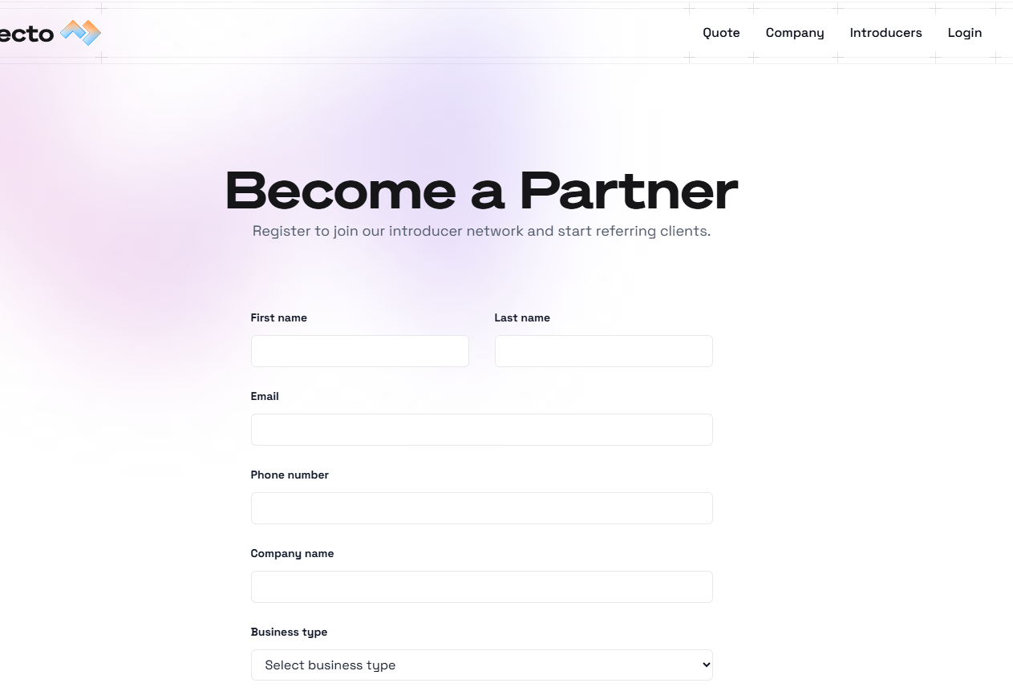
We want to add something similar to the below but add also add we pay £200 referral on completion, also add “get paid faster” we complete 80% faster than national average so get your commission faster

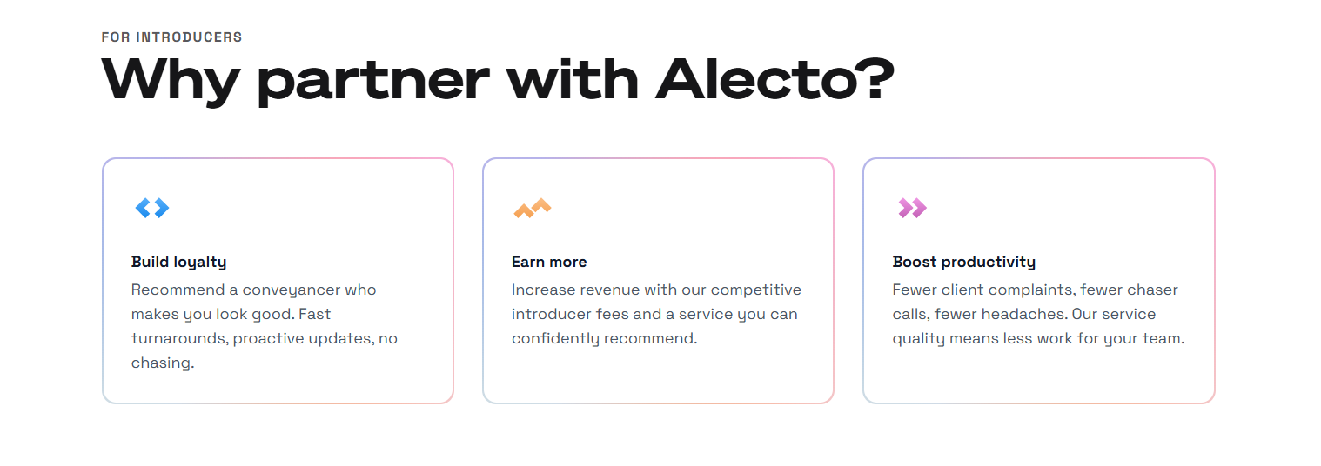

Reward “Blogs” With “Property Update”

We need a “Community Work” page
Content we can add
At Quality Conveyancing, we believe that true business success goes hand in hand with giving back. Our commitment to legal excellence is matched only by our dedication to supporting both local and global communities. For us, property law is about more than just contracts and completion dates—it is about helping people thrive wherever they are.
Locally, we proudly dedicate our time, resources, and sponsorship to impactful causes. This includes supporting vital organizations like Shooting Star Children’s Hospices—a charity that provides dedicated care for babies, children, and young people with life-limiting conditions, and their families, across Surrey and West London (see Image 1).
We have also proudly sponsored local team Handwell FH Whistlers FC for over six years, helping to mentor, inspire, and empower young people across our community.
FH Whistlers FC is far more than just a Saturday football team—it is a vital pillar of the local community. The club provides a safe, constructive space for young people to come together, build friendships, and open up about the real challenges they face every day. Beyond the pitch, the team encourages open conversations about work, education, and personal growth, with older players and coaches acting as positive role models to guide the next generation.
Our ongoing sponsorship directly supports these young players by providing essential football kits, training equipment, and matchday refreshments, as well as supporting local community initiatives like Handwell. By investing in FH Whistlers FC, we are helping to empower young people and build a stronger, more united local community.You can follo and support the FH Whistlers here @fhwhistlersfc : https://www.instagram.com/fhwhistlersfc?utm_source=ig_web_button_share_sheet&igsi=ZDNlZDc0MzIxNw==
Pictures below

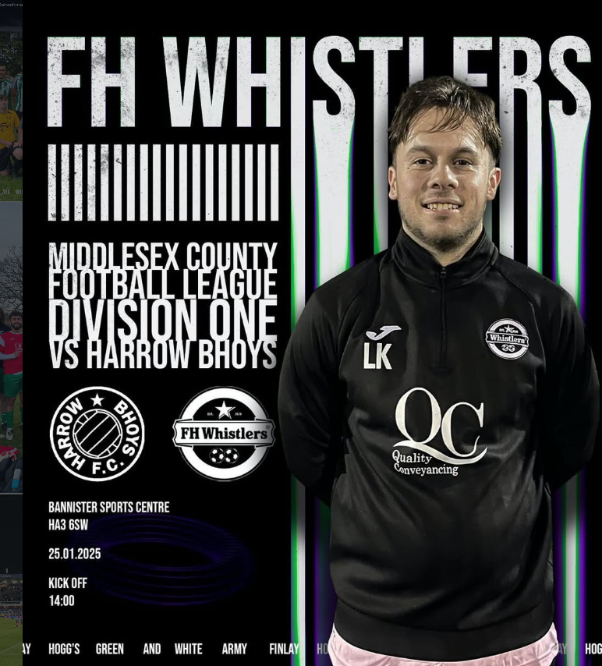
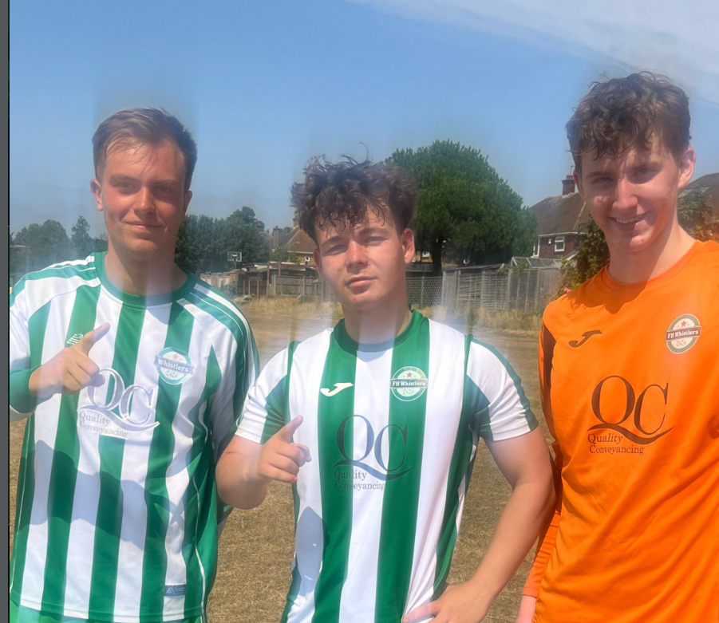

Beyond our local community, we actively support charities like Abayam, helping to transform healthcare and education for underprivileged and war-torn communities in Sri Lanka.

Other things;
- Please ensure the Whatsapp chat number is connected to this number 07843 476 594

- Add our Facebook/youtube/linkedin and instagram page to bottom of our site to encourage people to follow. Apurva will send you links for these

